BAHT Level I course
Examination Information

The BAHT Level I course examination has now moved ONLINE so that you can complete it after taking some time to consolidate your learning rather than having to cram for a written assessment at the end of the final day of your course.

There are a series of questions for you to complete, based on all aspects of the level I course content.

You will have 30 minutes to complete all the questions set and this time will automatically count down and run out at the designated time.

You must start and finish the examination in one sitting, you cannot take a break and go back to complete it later.

The exam is marked out of 50 and you need to score 60%, or 30/50 in order to pass.

The examination will be available from one minute past midnight tonight and stays open for 14 days (00:01 Saturday 26th March until 23:59 on Friday 8th April).

You may make ONE attempt at the examination during this initial two weeks.

Anyone who has been unsuccessful in their initial attempt will then be offered ONE further RESIT opportunity which can be accessed over the following two weeks.

In order to complete the examination you will need access to a computer with reliable internet connection and security settings that will allow you to use the host site (normal home broadband should be absolutely fine, but work based access will depend on the level of security settings set by your employer).

How to Register to access the BAHT level I online examination
Please read and follow these instructions carefully in order to be ready to access the online examination for your BAHT level I course. If you have any questions or difficulties contact your course provider for assistance – please DO NOT contact University of Essex (where the exam is hosted) or their IT services directly.
You should register ready for the BAHT level I online exam in advance of your course, so that assistance can be provided in good time if any difficulties are experienced. If you choose not to attempt to register for the first time until after your course when the exam deadline is approaching you do so at your own risk - extensions for completion of the exam will not be provided in these circumstances.
To successfully complete the registration process an ‘enrolment key’ which is unique to each course that runs is required. This will be given to you separately by your course provider.

Registration Step 1
You need to register an account with the University of Essex OpenEssex website (this is where the BAHT level I exam is hosted).
Open this link or type this address ( https://openessex.ac.uk) into your internet browser.
Follow the instructions given to create a new account, using your full name (the same as you gave to your course provider when registering for your course, so that your exam result can be matched to you).
An automated authentication email will be sent to the email address that you put in in order to complete registration process. Please check your junk/spam folder if it does not arrive in your inbox within a few minutes of putting in your details. Please also note that often nhs.net email accounts tend to block these automated emails so you may wish to use a different email address for your registration. The email address you provide will not be used for anything other than administration of the level I examination and will not be stored longer than needed for this purpose.
Make sure you keep a record of the username and password you set up for the account so that you can log back in as required.
NB If you happen to already have a University of Essex OpenEssex (formerly called MoodleX) account, just log in to this using your existing details and proceed to step 2 below.

Registration Step 2
1. Open this link or type this address ( https://openessex.ac.uk ) into your internet browser.
2. If you have just completed Step 1 you should already be logged in, but if prompted to log in enter your username and password to do so.
3. Go to Courses in the top bar and then All Courses in the drop down box
4. Click on Faculty of Science and Health
5. Click on School of Sport, Rehabilitation and Exercise Sciences
6. Click on BAHT Level I
You should then see the screen as shown below
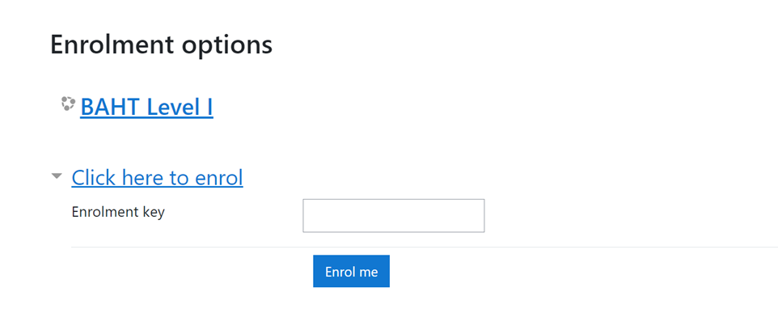
7. Type in the enrolment key and click “Enrol me.” (The enrolment key is BAHTNES0322b).
You are now fully registered, ready to complete your examination at the end of your course. See below for how to access a Test Quiz
To do a Test Quiz
You can follow the BAHT Level I link and to do a Test Quiz
1. Login to your account by using this link again or type this address ( https://openessex.ac.uk ) into your internet browser.
2. If you scroll down to the bottom of the page, you should find the BAHT Level I course link.
3. Or follow the steps above to the School of Sport, Rehabilitation and Exercise Sciences and find BAHT Level I link there.
4. Click on the BAHT Level I link
5. If you scroll to the bottom of the page, you will see the following options?
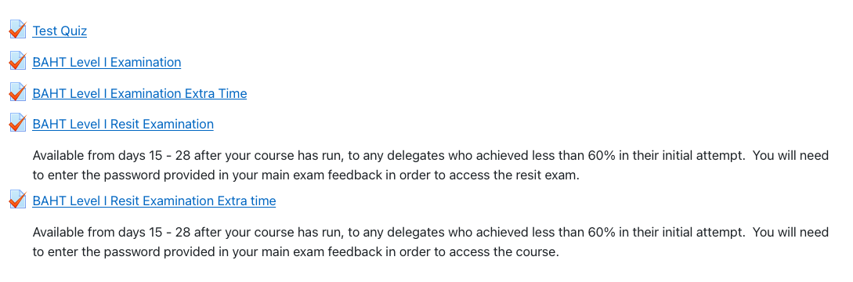
6. Click on Test Quiz and this will take you through a few question types, allow you to navigate between questions and see how the system works.
7. You will only be able to open the BAHT Level I Exam link from midnight of the last day of your course until midnight on the 14th day.

When you are ready to do the Exam –(you will only be able to do the exam once).
1. When you are ready to complete your exam, use this link again or type this address ( https://openessex.ac.uk ) into your internet browser. and then log in.
2. If you scroll down to the bottom of the page, you should find the BAHT Level I course link.
3. Or follow the steps above to the School of Sport, Rehabilitation and Exercise Sciences and find BAHT Level I link there.
4. Now click on the BAHT Level I Examination link and your exam will start.
5. if you have been given extra time for your exam you will be given a password to put in when you open the BAHT Level Examination Extra Time link.

Good luck!

Please contact your course provider if you have any questions or difficulties.

