Common Thumb splinting patterns

Radial forearm based thumb splint

Radial hand based MCP splint

Radial hand based CMC splint

Volar/dorsal MCPJ thumb splints

Wrap around /T-bar shapes

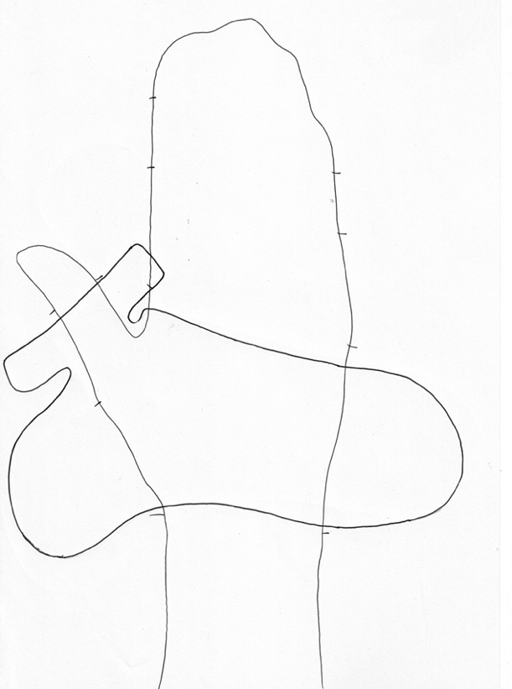

Volar/dorsal CMCJ thumb splints

Wrap and with MCPJ included

