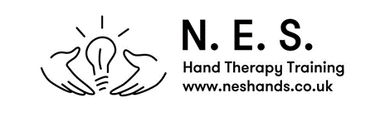

Reading List

Management of the PIP Joint

BAHT Level II

It is recommended that prior to the course some background reading is undertaken.

We would recommend that the most useful study you can undertake is reviewing the basic anatomy including muscle, bone, tendon, ligaments. This can be from any relevant texts / online learning.

The better your underlying anatomical knowledge the more you will benefit from the course.